
JAYPEE INSTITUTE OF INFORMATION TECHNOLOGY, NOIDA
(Deemed to be University u/s 3 of the UGC Act, 1956)
B.Tech. · Computer Science and Engineering
PROJECT SYNOPSIS
Minute: A Discord-Native Constrained Visual Change Loop
with Git Remaining on the Engineering Side
Table I. Project team
S.No. | Enrolment No. | Name | Batch
1 | 992401030328 | Aviral Agrawal | F-7
2 | 992401030337 | Aditya Sarna | F-7
3 | 992401030349 | Harshdeep Singh | F-7
4 | 992401030353 | Ashutosh Sharma | F-7

Supervisor: [Faculty Guide] · Department of CSE · JIIT Sector-128, Noida
Horizon: 12 weeks, six Scrum sprints · Academic year 2026 · 18 user stories

Abstract
Small visual work in a real repository still travels through a thick handoff: chat becomes a ticket, intent is rebuilt in a standup, and the proof is often a screenshot of staging. Minute is a Discord-only office bot. A non-technical person types /minute or @minute. Minute replies with a status, then a Playwright photograph of the running change on the branch it just edited, or it stops in ordinary English. Replies iterate in the same thread. “Looks good” opens a GitHub pull request whose wording comes from git diff. Tech reviews that pull request. Auth, payments, infrastructure and architecture are refused. The semester is Scrum: six two-week sprints, 18 stories, 112 Fibonacci points, planning velocity about 18–21 points a sprint. Diagrams are Mermaid figures. The stakeholder path is Discord; an operator screen and an install page are out of scope.
Keywords: Discord; constrained edit; visual proof; allowlist; Scrum; user story; planning poker; pull request; Playwright.

1. Problem and product
Someone writes “make the header a bit darker” in chat. A ticket is filed. The engineer was not in the first thread, so the intent is rebuilt. What comes back is a staging shot or “I updated the stylesheet.” Tools that keep git with engineering pull the requester into a tracker. Tools that stay in chat often let a model edit authentication and payments. Minute is the narrow case in between.
Fig. 1. As-is handoff (Mermaid). Chat → ticket → staging shot.
Fig. 2. Minute loop (Mermaid). Same thread; photo of this branch or an English stop.
Table II. Handoff, before and with Minute
 | Without Minute | With Minute
Ask lives | Chat, then a ticket | One Discord thread
Proof | Staging or a file list | Photo of this branch, or a stop
Git | Often in the conversation | Tech, on the pull request
Next tweak | A new ticket | A reply in the same thread

Minute is for a colour, a line of copy, a notes tab, a chart on a page tech has already allowed. It is not Slack, not a tracker, not a general coding agent, and not a way to generate an application. It does not merge its own pull requests and does not claim production safety. The photograph is the specification. Git stays with tech. One thread, one run, one pull request. /ready is five named gates. Caps on files, bytes and jobs are part of the rails.
Table III. Roles in one run
Role | Owns | Does not own
Requester | Intent and visual sign-off | Git, rails, merge
Minute | Smallest allowed change, or a stop; the photo | Whether production is safe
Tech | Rails, review, merge | Retyping chat into a ticket
Admin | Who may run Minute | The edit itself

2. How the semester will be run (Scrum)
The work is Scrum because the photograph, the refusals and the waiting time cannot be signed off on paper in week one [1]. Each two-week sprint ends with something visible in Discord (later also GitHub). Waterfall would hide the first honest photograph until the end. Kanban may be used later for a running bot; this term is Scrum. Inspect-and-adapt is aimed at three things: photo quality (is it this branch?), refuse accuracy (did a payments ask change a file?), and latency (did On it arrive before the person left?).
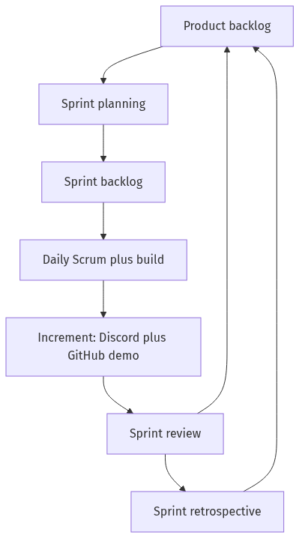
Fig. 3. Scrum cycle (Mermaid). The increment is a Discord/GitHub demo, not slides.
Scrum accountabilities sit on the student team and are not the product personas. One student is Product Owner (orders Table VI; is not the Discord requester). One is Scrum Master (time-boxes planning, daily Scrum, review, retro). All four are Developers (planning poker, increment, Definition of Done).
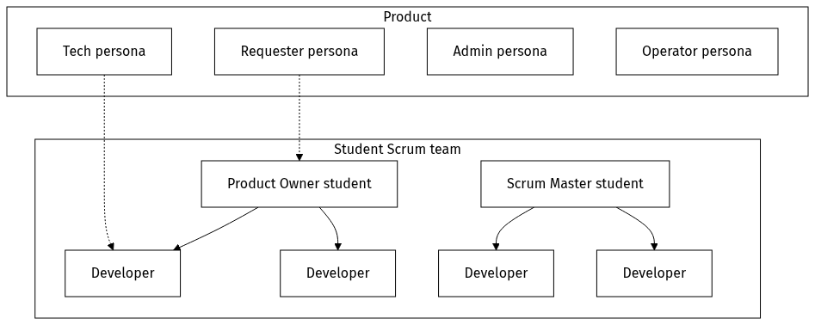
Fig. 4. Product personas versus student Scrum roles (Mermaid).
Table IV. Ceremonies
Ceremony | When | Output
Sprint planning | Start of each sprint, 45 min | Goal, committed IDs, points ≈ 18
Daily Scrum | Each lab day, 10 min | Blocks: intents, Chromium, tokens
Sprint review | End of sprint, 20 min | Faculty watches Discord / GitHub
Retrospective | After review, 15 min | One process change

Ready: persona named, given/when/then checks, rails effect known, estimate ≤ 13 (21 is split). Done: allowlist held; secrets out of logs, clone URLs and PR text; the thread has a photo of this branch or an English stop; if a PR opened, body from the diff; story checks passed. A staging screenshot is not done.
Planning poker uses 1, 2, 3, 5, 8, 13 [3]. Silent vote; speak only on disagreement. On this product: 1 = wording/config, 2 = small Discord reply, 3 = one external happy path, 5 = photo-pipeline slice or /ready, 8 = classify-and-edit, 13 = preview plus Playwright photo. Backlog = 112 points. Four students after classes → about 18–21 points a sprint. If the term runs short, drop US-17 and US-18 first, then US-15. Never drop US-06, US-07 or US-09.

3. Scope and system view
In scope. Discord only, one mapped channel; allow/revoke; classify tweak or stop; edit allowlisted paths; Playwright photo of this branch; replies in-thread; PR from diff; review news in-thread; attachments; /ready and caps.
Out of scope. Slack; generating an application; merge without tech; multi-tenant SaaS; marketing/OAuth install page; operator dashboard as a requester path.
Rails (YAML, written once by tech): one channel → one GitHub playground; allowlisted paths; refuse list; preview command. /ready is green only if Discord, Message Content, GitHub write, the model, and Chromium are all up. Otherwise Minute does not promise a photograph.
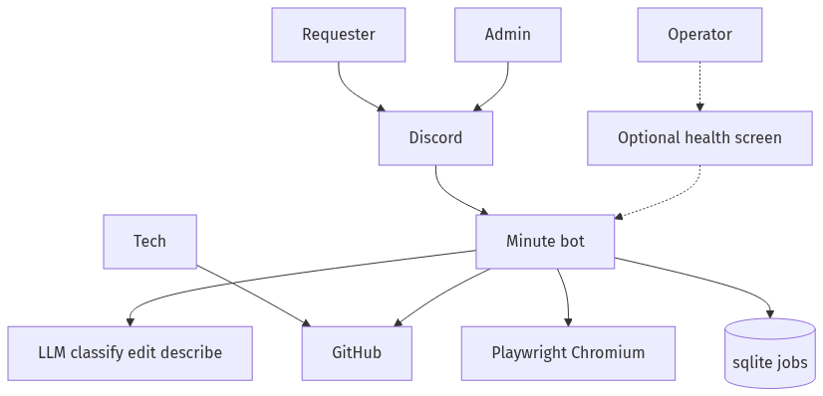
Fig. 5. System context (Mermaid). Optional health screen is off the requester path.
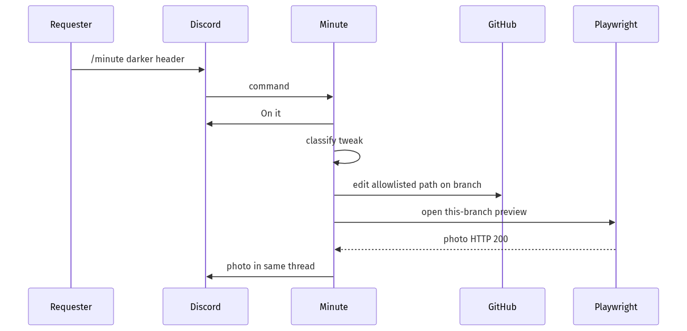
Fig. 6. Sequence: happy-path tweak (Mermaid).
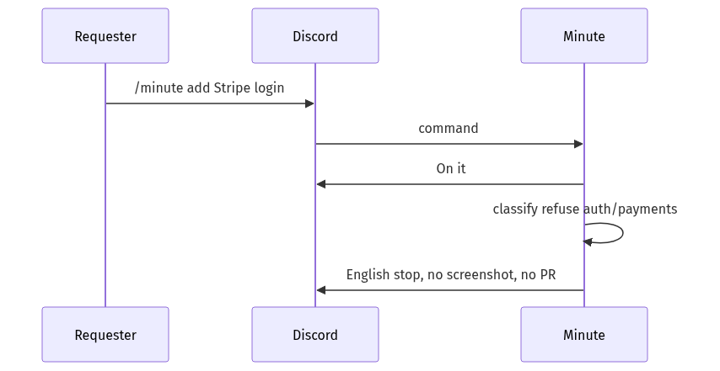
Fig. 7. Sequence: refuse (Mermaid). No screenshot, no PR.
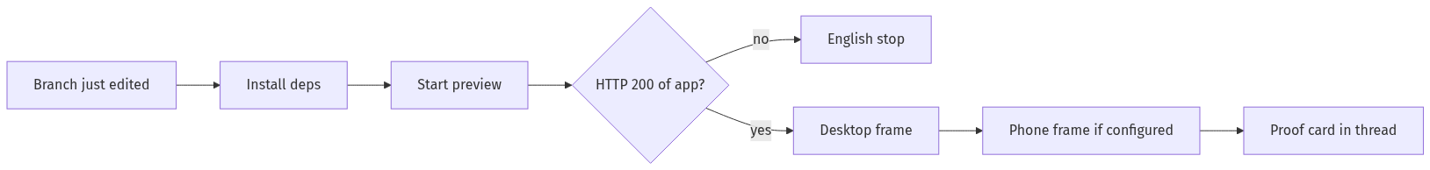
Fig. 8. Photo pipeline (Mermaid). HTTP 200 of this branch, or an English stop.
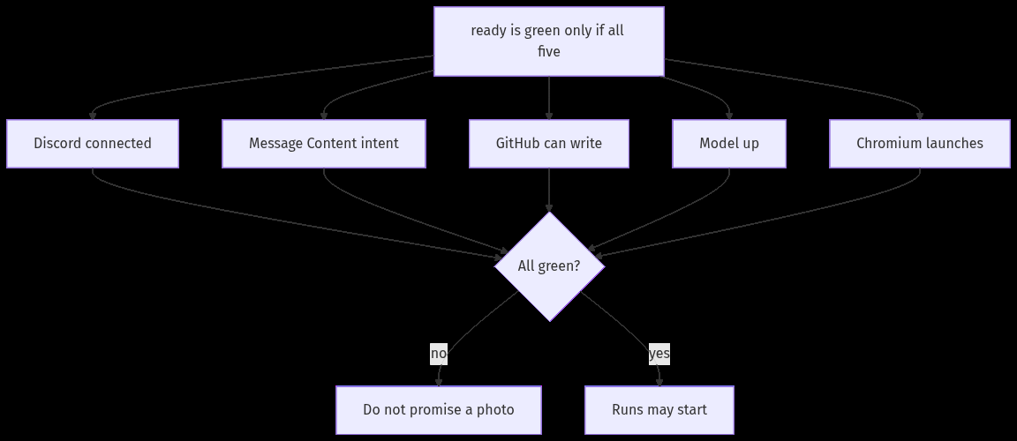
Fig. 9. /ready gates (Mermaid). Any red gate → no promised photo.
Table V. Functional requirements
Id | The system shall | Stories
FR-1 | Start from /minute or @minute in the mapped channel | US-05
FR-2 | Allow and revoke who may run it | US-02
FR-3 | Classify tweak or refuse | US-06, US-07
FR-4 | Change only allowlisted paths | US-08, US-16
FR-5 | Photograph this branch, or stop | US-09, US-10
FR-6 | Continue the same thread on reply | US-11
FR-7 | Open a PR from the diff and tell tech | US-12, US-13
FR-8 | Show review/merge in the thread | US-14
FR-9 | Handle attachments; ask if no caption | US-15
FR-10 | Report /ready as five named gates | US-04
FR-11 | Enforce caps and redact secrets | US-16

4. User stories and product backlog
Eighteen stories (cut from 33). Folded into neighbours: admin who, On it, phone viewport, tech ping, no-caption prompt, rate-limit retry, operator screen, install page, and the three spikes. Each remaining story is Independent, Negotiable, Valuable, Estimable, Small, Testable [2]. Checks are given/when/then in the lab: watch Discord or GitHub. US-09 is written in full below; the others are read the same way against Table VI.
Table VI. Product backlog in build order (18 stories, 112 pts)
# | Id | I want… | Pri. | Pts | Sp.
1 | US-01 | Message Content intent on the Discord app | Must | 3 | 1
2 | US-02 | Allow / revoke who may run /minute | Must | 5 | 1
3 | US-03 | One YAML playground per channel (repo, paths, refuse, preview) | Must | 5 | 1
4 | US-04 | /ready: Discord, intent, GitHub write, model, Chromium | Must | 5 | 1
5 | US-05 | /minute or @minute starts a run; On it before the photo | Must | 5 | 2
6 | US-06 | Refuse auth, payments, infra, architecture, secrets in English | Must | 8 | 2
7 | US-07 | A refused run has no screenshot and no pull request | Must | 3 | 2
8 | US-08 | Smallest allowlisted copy/layout edit; empty diff said plainly | Must | 8 | 2
9 | US-09 | Playwright photo of this branch (desktop; phone if configured) | Must | 13 | 3
10 | US-10 | Preview timeout or 404 ends in English; never a staging shot | Must | 5 | 3
11 | US-11 | Reply in the same thread continues the run | Must | 8 | 4
12 | US-12 | Looks good opens a PR; requester never sees git | Must | 5 | 4
13 | US-13 | PR title and body written from git diff; tech is pinged | Must | 5 | 4
14 | US-14 | Review / merge shown in the thread (webhook or poll) | Must | 8 | 5
15 | US-15 | Image, PDF or logo; ask Match / Spec / Put in repo if no caption | Should | 8 | 5
16 | US-16 | Caps on jobs, files and bytes; secrets redacted | Must | 5 | 5
17 | US-17 | Small scratch inside the rails, still proved with a photo | Should | 8 | 6
18 | US-18 | Ask about allowlisted files; no commit | Should | 5 | 6

Table VII. MoSCoW
Priority | Count | Points
Must | 15 | 91
Should | 3 | 21
All | 18 | 112

US-09 (full). As a requester, I want a Playwright photo of the running page on this branch so that the picture is what I am signing off.
Given the playground preview returns HTTP 200 from the branch just edited, when the run reaches proof, then an image of that page is posted in the same Discord thread.
Given Chromium cannot be launched, when /ready is called, then that gate is red and the thread is told. No earlier screenshot is substituted.
Given a staging deployment of another branch is reachable, when proof runs, then that deployment is not used. Viewport set and timeout wording stay in US-10 so a missing photograph is not marked done because a pull request exists.

5. Six sprints and twelve-week Gantt
Each sprint has one testable sentence. Demos at the end of sprints 2, 4 and 6: refusal; pull request; full thread (or walking skeleton if Should-haves were cut). Walking skeleton: US-04, US-05, US-06, US-07, US-08, US-09.
Table VIII. Sprint scope
Sp. | Weeks | Goal | Stories | Pts
1 | 1–2 | Discord, access, rails, honest /ready | US-01–04 | 18
2 | 3–4 | A real ask, and a refusal that changes nothing | US-05–08 | 24
3 | 5–6 | A photograph of this branch, or a straight failure | US-09, US-10 | 18
4 | 7–8 | Replies, then a pull request for tech | US-11–13 | 18
5 | 9–10 | Review news, files, caps | US-14–16 | 21
6 | 11–12 | Ask and small scratch (cut first if short) | US-17, US-18 | 13

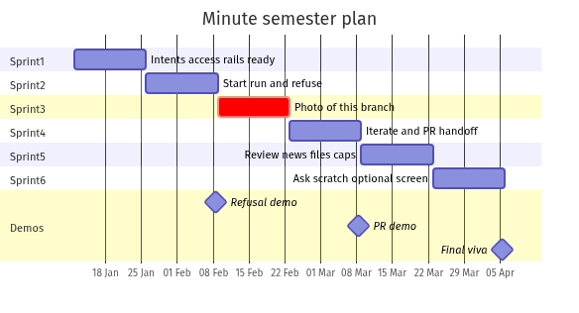
Fig. 10. Twelve-week Gantt, six sprints (Mermaid).
Table IX. Gantt (█ work, ◆ review). Dates follow the institute calendar.
Item | W1–2 | W3–4 | W5–6 | W7–8 | W9–10 | W11–12
S1 access /ready | █
S2 start + refuse |  | █ ◆
S3 photo |  |  | █
S4 iterate + PR |  |  |  | █ ◆
S5 review / files / caps |  |  |  |  | █
S6 ask / scratch / viva |  |  |  |  |  | █ ◆

6. Risks and close
Table X. Risks
Risk | If it happens | Inside this scope
Message Content off | Replies never arrive | /ready red; do not fake iterate
Chromium missing | No honest photograph | US-04, US-10; no staging stand-in
Model down | Edits stall | Stop rather than edit; On it still posts
Token wider than playground | Damage outside the repo | Part of US-16, not a later extra
Scratch read as “build an app” | Product drifts | US-17 stays in rails or stops
No public URL for webhooks | Review news is late | US-14: poll is enough

A constrained editor is not a substitute for an engineer. The term will not scrape secrets, will not merge alone, and will not treat a refusal as an embarrassment. .env is not committed. After twelve weeks: a lab Minute that can stop, change a playground inside the list, show the page, take a reply, and hand tech a pull request. Not a hosted product. Not any chat other than Discord. Table VI is the scope we will accept or cut; we will not swap it for a wider tool mid-semester.

References
[1] K. Schwaber and J. Sutherland, The Scrum Guide, Nov. 2020. https://scrumguides.org/
[2] M. Cohn, User Stories Applied. Addison-Wesley, 2004.
[3] M. Cohn, Agile Estimating and Planning. Prentice Hall, 2005.
[4] ISO/IEC/IEEE 29148:2018, Requirements engineering.
[5] Discord Developer Documentation. https://discord.com/developers/docs
[6] Playwright documentation. https://playwright.dev
[7] GitHub REST API, pull requests. https://docs.github.com/en/rest
[8] Mermaid documentation. https://mermaid.js.org/
[9] K. S. Rubin, Essential Scrum. Addison-Wesley, 2012.
[10] N. Forsgren, J. Humble and G. Kim, Accelerate. IT Revolution, 2018.

